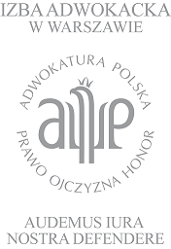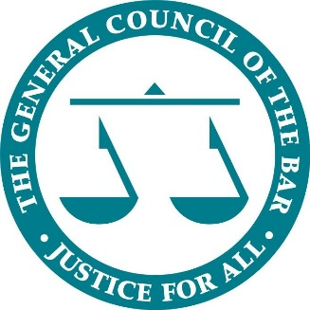
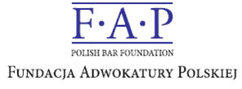

Bar Council of England and Wales
Warsaw Bar Association
Polish Bar Foundation

English-Polish Law Day:
Current bilateral issues in
Family Law and Criminal Law

Monday 15 May 2017
Warsaw Bar Association, Aleje Ujazdowskie 49

Seminar, 9:30-17:15  (registration and coffee from 9:00 am) | Networking Reception, 17:15-19:00

Seminar Programme

9:00 | Registration & Coffee
9:30 | Welcome and Introduction  Andrew Langdon QC – Chairman, The General Council of the Bar  Mikołaj Pietrzak – Dean, The Warsaw Bar
 | Criminal Law Programme
9:30 – 10:45 | Session 1 – Mutual Legal Assistance in British-Polish Asset Recovery  National criminal proceedings and provision for mutual legal assistance in support of those proceedings and criminal/civil asset recovery. | Moderator:  Dominika Stępińska-Duch  Panelists:  Janusz Tomczak  Szymon Pawelec  Barnaby Hone  Fiona Jackson
10:45 – 11:15 | Coffee Break
11:15 – 12:30 | Session 2 – The European Arrest Warrant in British-Polish Criminal Cases  Seeking the extradition of suspects from either jurisdiction under the EAW scheme, and tips on how to counter such applications. | Moderator:  Andrew Langdon QC  Panelists:  Katarzyna Wiśniewska  Urszula Podhalańska  Ben Cooper  Laura Herbert
12:30 – 14:00 | Lunch
 | Family Law Programme: “A Comparison - Family Law in Poland and England and Wales”
14:00 – 15:15 | Session 1 - Money Matters  The division of financial resources on divorce and the relevance of prenuptial agreements. | Moderator:  Philip Marshall QC  Panelists:  Jacek Wierciński  Karolina Bodnar  Ann Hussey QC  Sarah Lucy Cooper
15:15 – 15:45 | Coffee Break
15:45 – 17:00 | Session 2 - Families across Frontiers  The law and practice of moving children from one jurisdiction to another. | Moderator:  Monika Gąsiorowska  Panelists:  Maria Keller-Hamela  Kamila Zagórska  Edward Devereux QC  Soraya Pascoe
17.00-17.15 | Closing Remarks  Andrew Langdon QC – Chairman, The General Council of the Bar  Mikolaj Pietrzak – Dean, The Warsaw Bar
17:15 – 19:00 | Reception

